Icons For Your Mobile Applications

LongRange provides a set of custom-made icons which you can use in your applications:
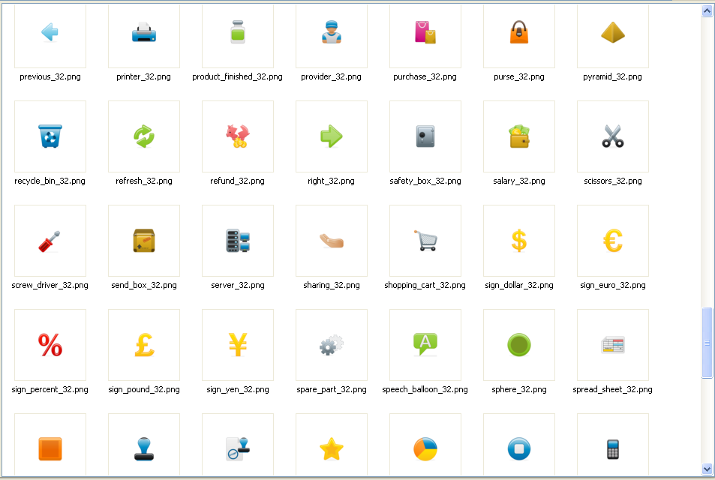

These icons can be found in the LongRange resource folder:
- LongRange RPG: LongRange\resource under your aXes root folder.
- LongRange LANSA: LongRange\resource under <lansa root folder>\webserver\images.

If you cannot find suitable icons in this collection, you can get icon sets on the web for very little.
For example the company which created the LongRange icons, iconshock (www.iconshock.com), sells a huge selection of stock icons and icon sets including icons for iPhone/iPad and Android:
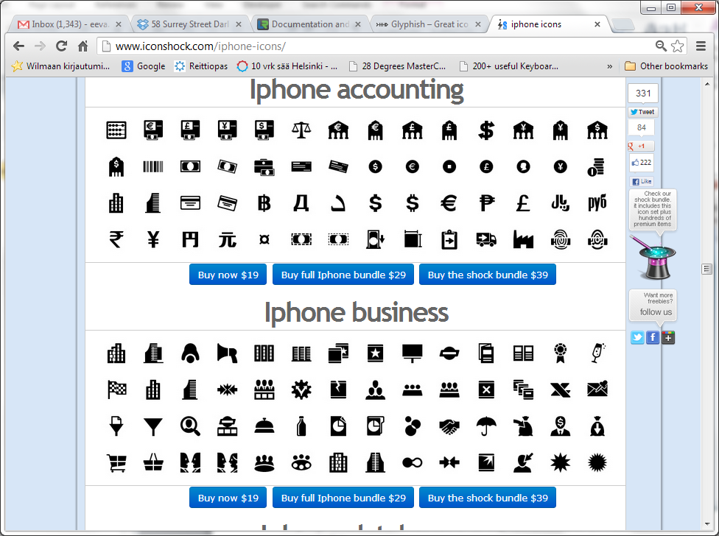
We cannot cannot redistribute these icons for licensing reasons, but you can purchase them for use in your own applications.
Another useful collection is www.glyphish.com:
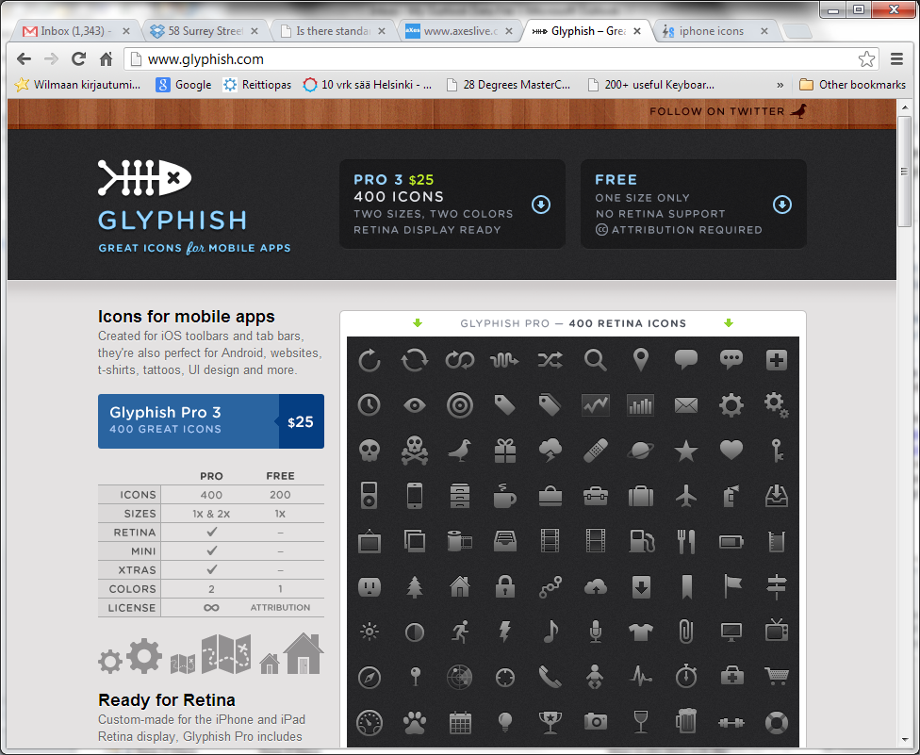

Here is an example of a LongRange application which uses the Glyphish Pro icon set in the tab bar on the bottom of the screen:
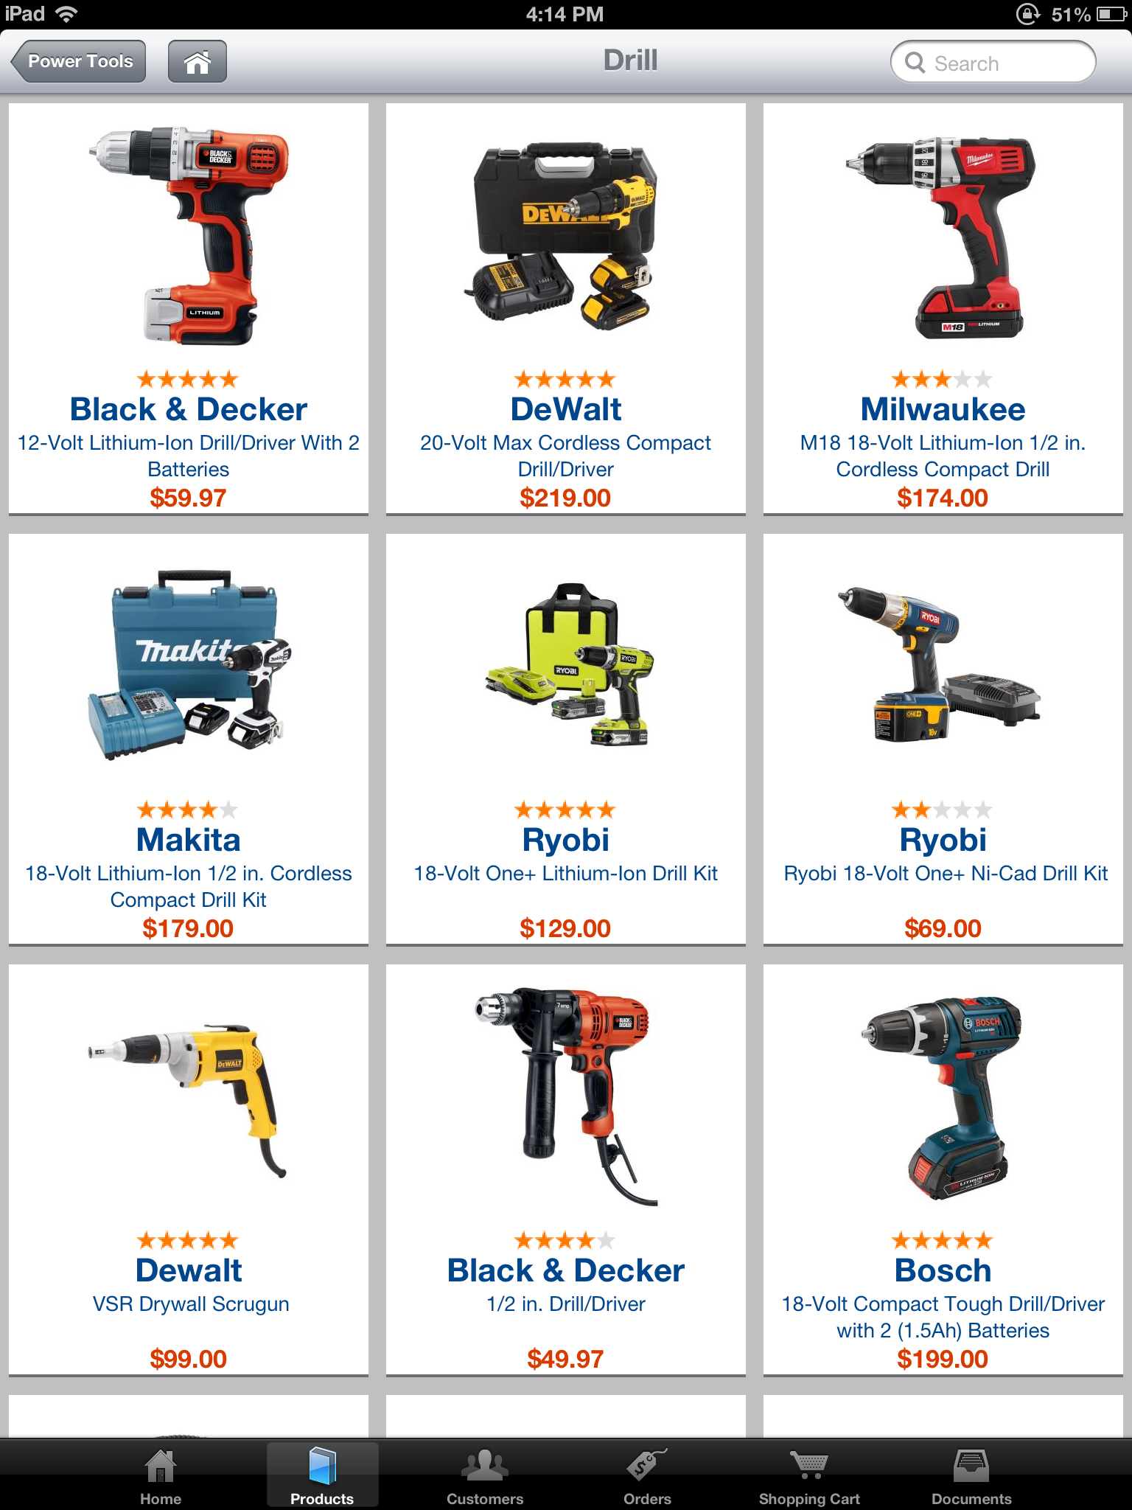

All icons must be copied to the LongRange\resource directory so that the LongRange client running on a mobile device can find them.

Note for LongRange RPG
When using LongRange for RPG you need to make sure that any new icons you add to your Resource folder have user *PUBLIC with *R rights only.
For example use command WRKLNK OBJ('/axes/LongRange/resource') then use 5=Display to display the files in the resource folder:
- For each new icon file use 9=Work with authority to check that user *PUBLIC and *R rights only.
- When required use option 2=Change user authority to adjust.


