- ‘Job’ dropDown initially populated upon selection of customer. In this case, the dropDown list contains over a hundred list items.
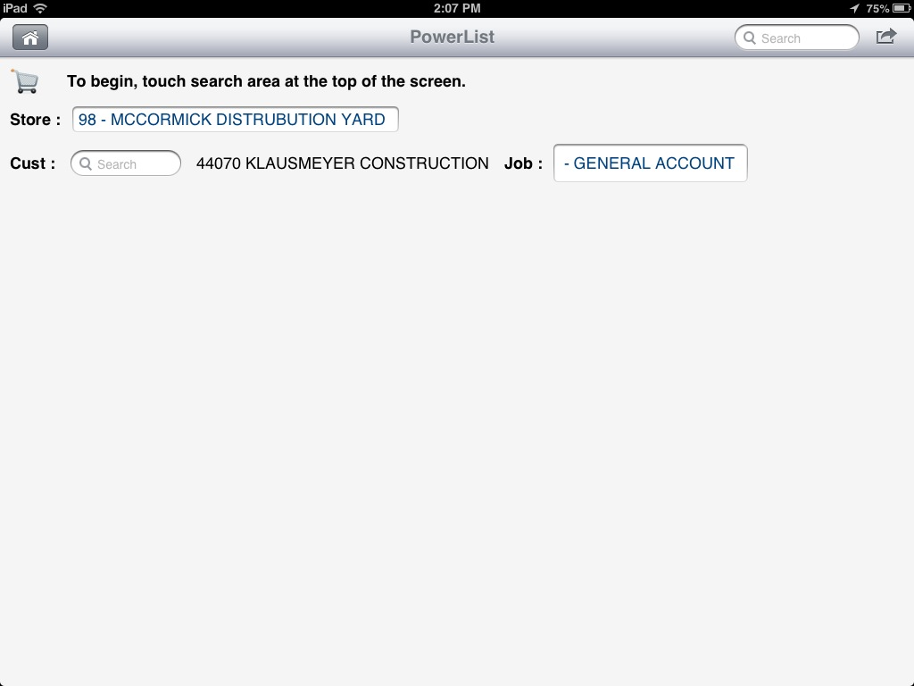
- When user touches the ‘Job’ dropDown, the list items are displayed. The first list item is ‘Filter List…’
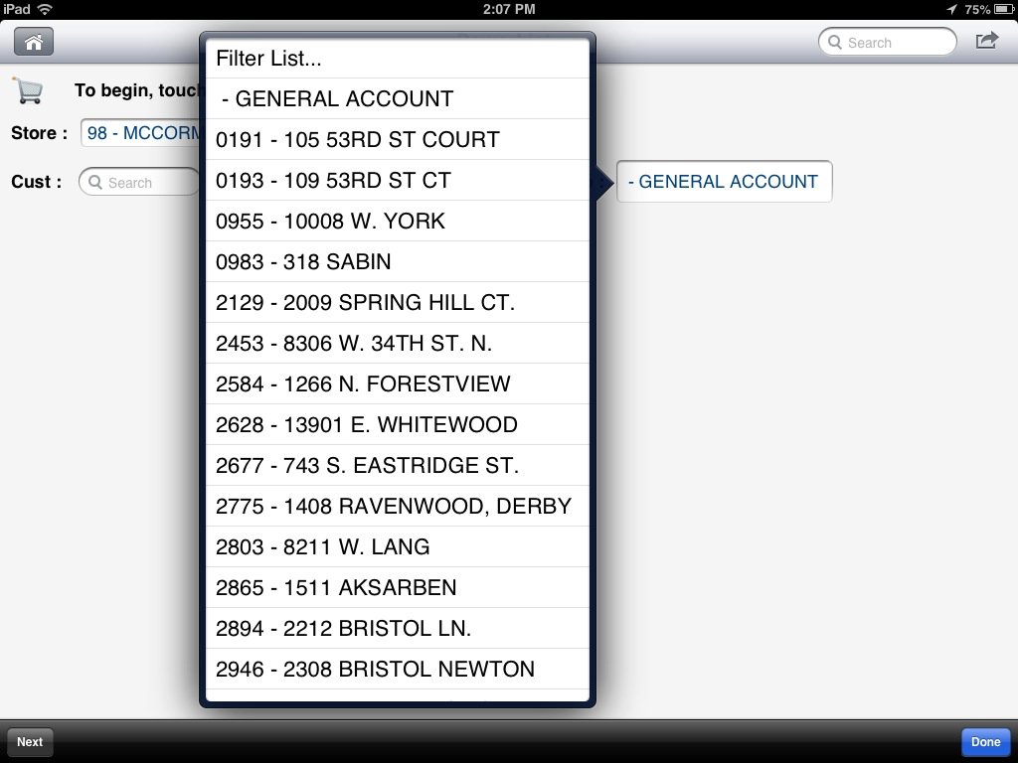
- Touching the ‘Filter List…’ list item displays a popOver form, allowing entry of a ‘contains’ string that will be used to filter the list.
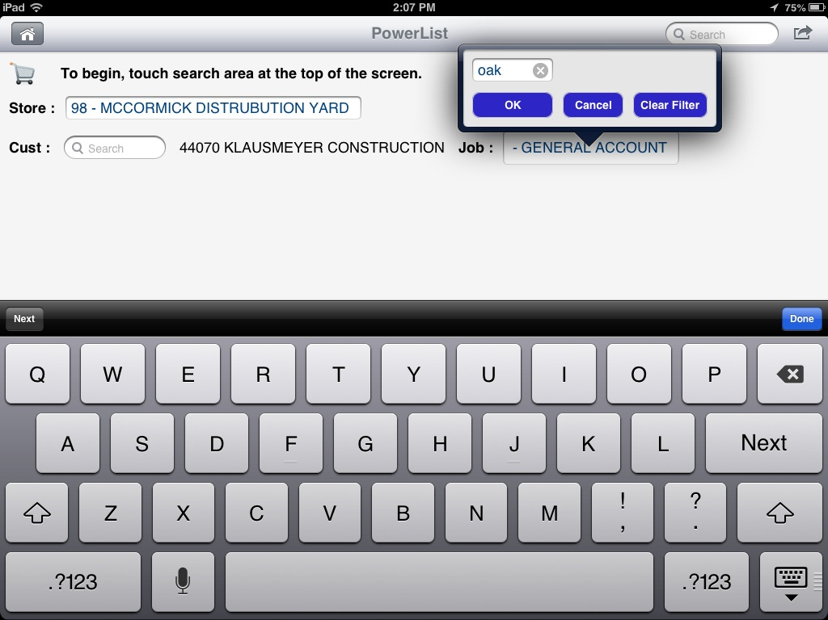
- The filtered dropDown is then displayed…
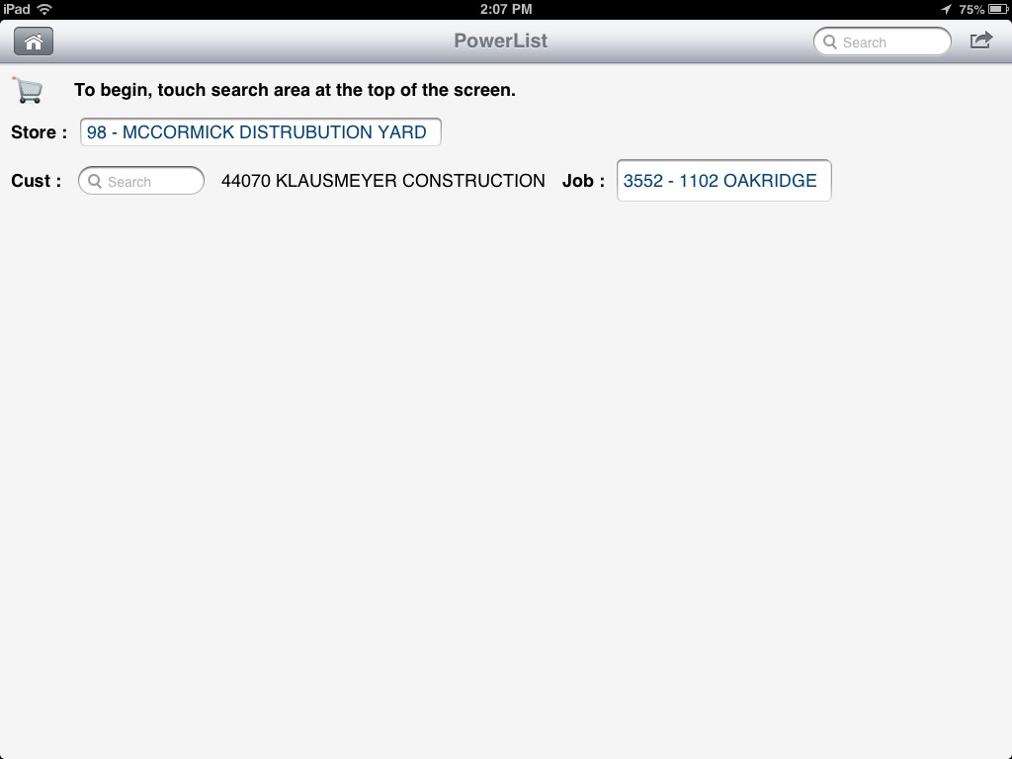
- But what I’d like to have happen is to be able to display the filtered list “expanded” so that the user doesn’t have to touch the dropDown to view the filtered items…


