Some of the changes you will notice when using the new iOS7 version on an iOS7 device are …..
LongRange itself has a new ‘flat’ iOS7 style icon:
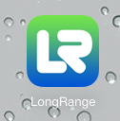
The appearance of menus has changed slightly and the icons are now blue:
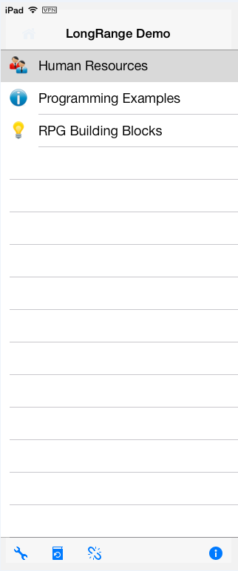
Command buttons and icons have changed to use the new iOS7 standard:
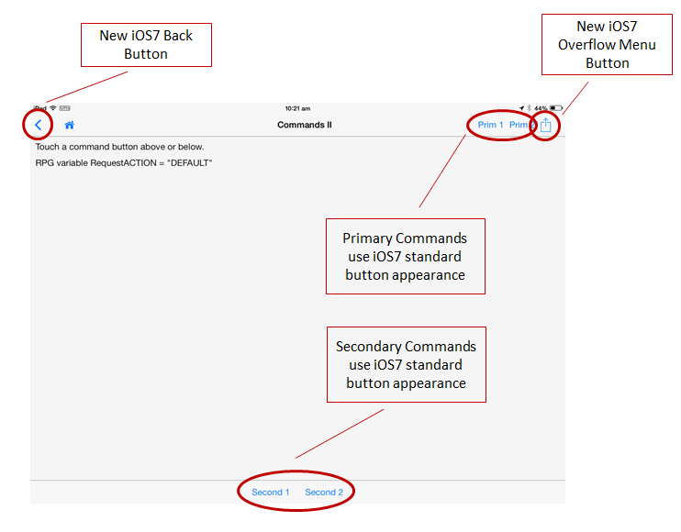
Overflow menus have a new iOS7 appearance:
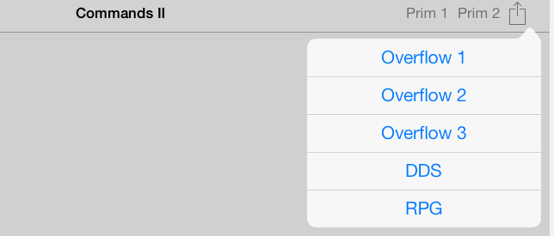
New iOS7 date and time pickers:
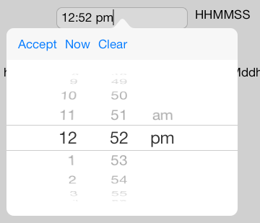
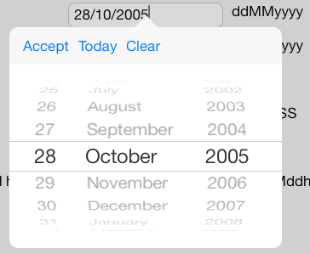
Popovers no longer have borders:
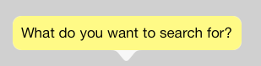
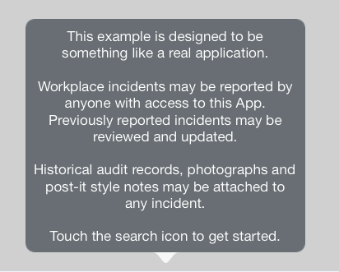
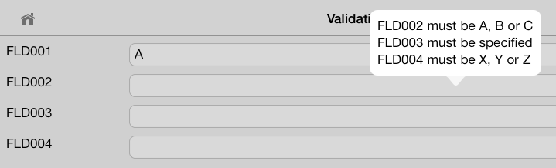
iOS7 push buttons now appear as blue text by default - unless you have altered their characteristics:


