Offline EZI Example
This is a minimalist example of using EZI panels and tables in offline (or local) forms.
It demonstrates common header -> details type local form interactions.
Requires RV16 on client and on RPG server.

Local Tables Used

The HEADER Table

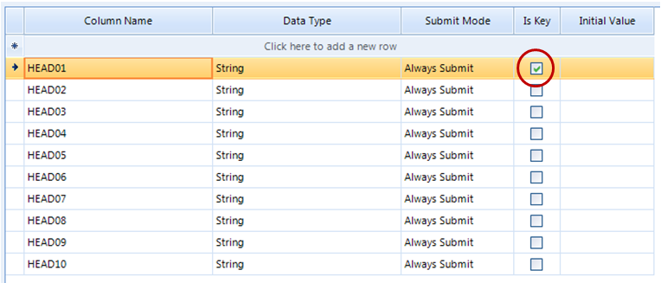

The ITEMS table
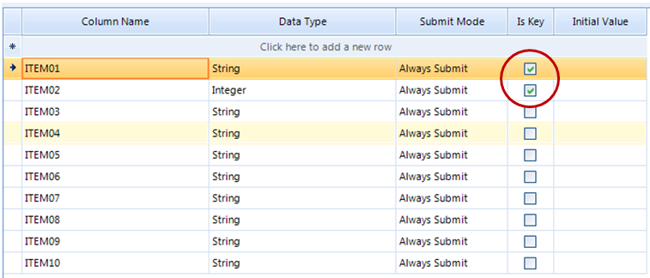

Form Views Used
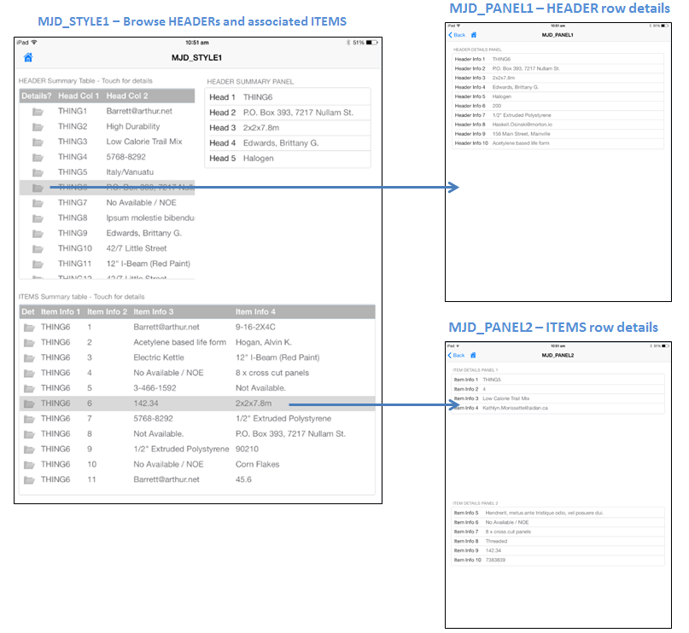

RPG Programs Source Code

MJD_DOWN – Download sample HEADER and ITEMS rows
Defined as an online form view and attached to the schema’s main menu
H BNDDIR('LRNGSRV') DFTACTGRP(*no) ACTGRP(*caller)
H BNDDIR('EZISERVICE')
/INCLUDE LRNGSOURCE,LRNGCOMMON
/INCLUDE SOURCEDEMO,DEMOCOMMON
/INCLUDE QRPGLESRC,EZISERVICE
* ------------------------------
* The HEADER table is defined as
* ------------------------------
* HEAD01 - String (KEY)
* HEAD02 - String
* HEAD03 - String
* HEAD04 - String
* HEAD05 - String
* HEAD06 - String
* HEAD07 - String
* HEAD08 - String
* HEAD09 - String
* HEAD10 - String
* -----------------------------
* The ITEMS table is defined as
* -----------------------------
* ITEM01 - String (KEY)
* ITEM02 - Integer (KEY)
* ITEM03 - String
* ITEM04 - String
* ITEM05 - String
* ITEM06 - String
* ITEM07 - String
* ITEM08 - String
* ITEM09 - String
* ITEM10 - String
* ----------------------------------------------------------
D MaxHeaders C 50
D MinItems C 3
D MaxItems C 30
* ----------------------------------------------------------
D HeaderRows S 10I00 Inz(0)
D ItemRows S 10I00 Inz(0)
D Item S 10I00 Inz(0)
D Rand S 10I00 Inz(0)
/INCLUDE SOURCEDEMO,STDPARAMS
/free
// ----------------------------------------------------------
Exsr DownLoad_Data;
EZI_OK_MessageBox('COMPLETION'
: 'Uploaded ' + %char(HeaderRows) + ' HEADER table rows '
+ ' and ' + %char(ItemRows) + ' ITEMS table rows.' );
LRNG_SendReceive(False:RequestPROGRAM:RequestACTION);
*InLR = True;
Return;
// ----------------------------------------------------------
BegSr DownLoad_Data;

// Empty the client side tables - use 'Presend' SQL commands

LRNG_UsingEx(False:'/DB.Presend');
LRNG_SetProperty( 'SQL%1' : 'DELETE FROM HEADER');
LRNG_SetProperty( 'SQL%2' : 'DELETE FROM ITEMS');
LRNG_EndUsing();

// Send the HEADER rows
LRNG_SetProperty('/DB.Table%1' : 'HEADER');
For HeaderRows = 1 to MaxHeaders;
EZI_Offline_SendTableRow( 1
: HeaderRows
: 'HEAD01' : 'THING'+ %char(HeaderRows)
: 'HEAD02' : EZI_RandomString('D')
: 'HEAD03' : EZI_RandomString('D')
: 'HEAD04' : EZI_RandomString('D')
: 'HEAD05' : EZI_RandomString('D')
: 'HEAD06' : EZI_RandomString('D')
: 'HEAD07' : EZI_RandomString('D')
: 'HEAD08' : EZI_RandomString('D')
: 'HEAD09' : EZI_RandomString('D')
: 'HEAD10' : EZI_RandomString('D') );
EndFor;

// Send ITEMS rows
LRNG_SetProperty( '/DB.Table%2' : 'ITEMS');
For HeaderRows = 1 to MaxHeaders;
Rand = EZI_GetRandomNumber(MinItems:MaxItems);
For Item = 1 to Rand;
ItemRows += 1;
EZI_Offline_SendTableRow( 2
: ItemRows
: 'ITEM01' : 'THING'+%char(HeaderRows)
: 'ITEM02' : %char(Item)
: 'ITEM03' : EZI_RandomString('D')
: 'ITEM04' : EZI_RandomString('D')
: 'ITEM05' : EZI_RandomString('D')
: 'ITEM06' : EZI_RandomString('D')
: 'ITEM07' : EZI_RandomString('D')
: 'ITEM08' : EZI_RandomString('D')
: 'ITEM09' : EZI_RandomString('D')
: 'ITEM10' : EZI_RandomString('D') );
EndFor;
EndFor;
HeaderRows -= 1;

// Finished

EndSr;
/end-free

MJD_PANEL1 – HEADER row details
Defined as an offline/local form view, but not attached to the schema’s main menu
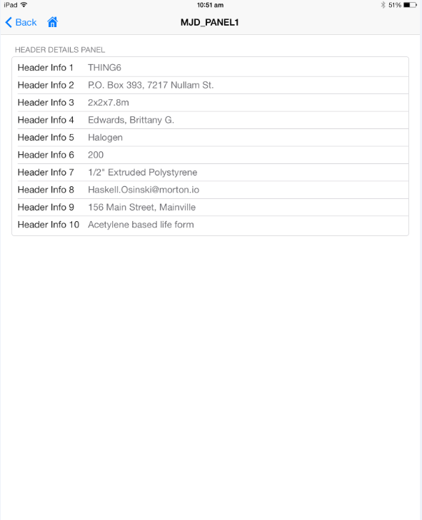
H BNDDIR('LRNGSRV') DFTACTGRP(*no) ACTGRP(*caller)
H BNDDIR('EZISERVICE')
/INCLUDE LRNGSOURCE,LRNGCOMMON
/INCLUDE QRPGLESRC,EZISERVICE
/INCLUDE SOURCEDEMO,DEMOCOMMON
* Define the Header details panel
D Head_Panel Ds LikeDS(EZI_QPanel) Inz(*LikeDS)
D Panel_Elem1 Ds LikeDS(EZI_Label) Inz(*LikeDS)
D Panel_Elem2 Ds LikeDS(EZI_Label) Inz(*LikeDS)
D Panel_Elem3 Ds LikeDS(EZI_Label) Inz(*LikeDS)
D Panel_Elem4 Ds LikeDS(EZI_Label) Inz(*LikeDS)
D Panel_Elem5 Ds LikeDS(EZI_Label) Inz(*LikeDS)
D Panel_Elem6 Ds LikeDS(EZI_Label) Inz(*LikeDS)
D Panel_Elem7 Ds LikeDS(EZI_Label) Inz(*LikeDS)
D Panel_Elem8 Ds LikeDS(EZI_Label) Inz(*LikeDS)
D Panel_Elem9 Ds LikeDS(EZI_Label) Inz(*LikeDS)
D Panel_Elem10 Ds LikeDS(EZI_Label) Inz(*LikeDS)

* Standard form view handler parameter list declaration
/INCLUDE SOURCEDEMO,STDPARAMS

/free
// Bind everything at the form level
LRNG_UsingEx(False:'/Form.&');
LRNG_SetProperties('TBL: HEADER'
:'ASVIEW:'+ ProgramINFO.Name
:'SQL: SELECT ROWID, +
HEAD01, HEAD02, HEAD03, HEAD04, HEAD05, +
HEAD06, HEAD07, HEAD08, HEAD09, HEAD10 +
FROM HEADER +
WHERE ROWID = &(FLD:CURRENT_HEADER.ROWID)' );
LRNG_EndUsing();
// Define the overall form grid layout
LRNG_SetProperties( '/Form.Grid.Col%1.Width:Fill'
: '/Form.Grid.Row%1.Height:Fill' );
// Define the tables and panels on the form view
Exsr Define_Header_Panel;
// Send the form view template back and finish.
LRNG_SendReceive(False:RequestPROGRAM:RequestACTION);
*InLR = True;
Return;

// --------------------------------------------------------------------

Begsr Define_Header_Panel;

// Position on main form
Head_Panel.ParentGRow = 1;
Head_Panel.ParentGCol = 1;

// Set up the panel elements
Panel_Elem1.Label = 'Header Info 1';
EZI_QPanel_DefineItem( Head_Panel : Panel_Elem1 );

Panel_Elem2.Label = 'Header Info 2';
EZI_QPanel_DefineItem( Head_Panel : Panel_Elem2 );

Panel_Elem3.Label = 'Header Info 3';
EZI_QPanel_DefineItem( Head_Panel : Panel_Elem3 );

Panel_Elem4.Label = 'Header Info 4';
EZI_QPanel_DefineItem( Head_Panel : Panel_Elem4 );

Panel_Elem5.Label = 'Header Info 5';
EZI_QPanel_DefineItem( Head_Panel : Panel_Elem5 );

Panel_Elem6.Label = 'Header Info 6';
EZI_QPanel_DefineItem( Head_Panel : Panel_Elem6 );

Panel_Elem7.Label = 'Header Info 7';
EZI_QPanel_DefineItem( Head_Panel : Panel_Elem7 );

Panel_Elem8.Label = 'Header Info 8';
EZI_QPanel_DefineItem( Head_Panel : Panel_Elem8 );

Panel_Elem9.Label = 'Header Info 9';
EZI_QPanel_DefineItem( Head_Panel : Panel_Elem9 );

Panel_Elem10.Label = 'Header Info 10';
EZI_QPanel_DefineItem( Head_Panel : Panel_Elem10 );

// Define the panel
Head_Panel.Title = 'Header Details Panel';
EZI_QPanel_Define( Head_Panel );

// Bind the panel elements to the SQL values retreived

EZI_BindProperty( Panel_Elem1 : 'TEXT' : 'FLD' : 'HEAD01');
EZI_BindProperty( Panel_Elem2 : 'TEXT' : 'FLD' : 'HEAD02');
EZI_BindProperty( Panel_Elem3 : 'TEXT' : 'FLD' : 'HEAD03');
EZI_BindProperty( Panel_Elem4 : 'TEXT' : 'FLD' : 'HEAD04');
EZI_BindProperty( Panel_Elem5 : 'TEXT' : 'FLD' : 'HEAD05');
EZI_BindProperty( Panel_Elem6 : 'TEXT' : 'FLD' : 'HEAD06');
EZI_BindProperty( Panel_Elem7 : 'TEXT' : 'FLD' : 'HEAD07');
EZI_BindProperty( Panel_Elem8 : 'TEXT' : 'FLD' : 'HEAD08');
EZI_BindProperty( Panel_Elem9 : 'TEXT' : 'FLD' : 'HEAD09');
EZI_BindProperty( Panel_Elem10: 'TEXT' : 'FLD' : 'HEAD10');

Endsr;

/end-free

MJD_PANEL2 – ITEMS row details
Defined as an offline/local form view, but not attached to the schema’s main menu
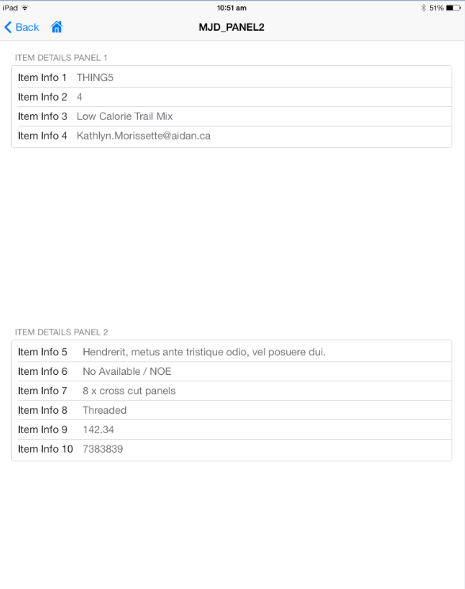
H BNDDIR('LRNGSRV') DFTACTGRP(*no) ACTGRP(*caller)
H BNDDIR('EZISERVICE')
/INCLUDE LRNGSOURCE,LRNGCOMMON
/INCLUDE QRPGLESRC,EZISERVICE
/INCLUDE SOURCEDEMO,DEMOCOMMON
* Define the item details panel 1
D Item_Panel1 Ds LikeDS(EZI_QPanel) Inz(*LikeDS)
D Panel_Elem1 Ds LikeDS(EZI_Label) Inz(*LikeDS)
D Panel_Elem2 Ds LikeDS(EZI_Label) Inz(*LikeDS)
D Panel_Elem3 Ds LikeDS(EZI_Label) Inz(*LikeDS)
D Panel_Elem4 Ds LikeDS(EZI_Label) Inz(*LikeDS)
* Define the item details panel 2
D Item_Panel2 Ds LikeDS(EZI_QPanel) Inz(*LikeDS)
D Panel_Elem5 Ds LikeDS(EZI_Label) Inz(*LikeDS)
D Panel_Elem6 Ds LikeDS(EZI_Label) Inz(*LikeDS)
D Panel_Elem7 Ds LikeDS(EZI_Label) Inz(*LikeDS)
D Panel_Elem8 Ds LikeDS(EZI_Label) Inz(*LikeDS)
D Panel_Elem9 Ds LikeDS(EZI_Label) Inz(*LikeDS)
D Panel_Elem10 Ds LikeDS(EZI_Label) Inz(*LikeDS)

* Standard form view handler parameter list declaration
/INCLUDE SOURCEDEMO,STDPARAMS

/free
// Bind everything at the form level
LRNG_UsingEx(False:'/Form.&');
LRNG_SetProperties('TBL: ITEMS'
:'ASVIEW:'+ ProgramINFO.Name
:'SQL:SELECT ROWID, +
ITEM01,ITEM02,ITEM03,ITEM04,ITEM05,+
ITEM06,ITEM07,ITEM08,ITEM09,ITEM10 +
FROM ITEMS +
WHERE ROWID = &(FLD:CURRENT_ITEM.ROWID)' );
LRNG_EndUsing();
// Define the overall form grid layout
LRNG_SetProperties( '/Form.Grid.Row%1.Height:Fill'
: '/Form.Grid.Row%2.Height:Fill' );
// Define the two panels on the form view
Exsr Define_Item_Panel1;
Exsr Define_Item_Panel2;
// Send the form view template back and finish.
LRNG_SendReceive(False:RequestPROGRAM:RequestACTION);
*InLR = True;
Return;

// --------------------------------------------------------------------

Begsr Define_Item_Panel1;

// Position on main form
Item_Panel1.ParentGRow = 1;
Item_Panel1.ParentGCol = 1;

// Set up the panel elements
Panel_Elem1.Label = 'Item Info 1';
EZI_QPanel_DefineItem( Item_Panel1 : Panel_Elem1 );

Panel_Elem2.Label = 'Item Info 2';
EZI_QPanel_DefineItem( Item_Panel1 : Panel_Elem2 );

Panel_Elem3.Label = 'Item Info 3';
EZI_QPanel_DefineItem( Item_Panel1 : Panel_Elem3 );

Panel_Elem4.Label = 'Item Info 4';
EZI_QPanel_DefineItem( Item_Panel1 : Panel_Elem4 );

// Define the panel
Item_Panel1.Title = 'ITEM Details Panel 1';
EZI_QPanel_Define( Item_Panel1 );

// Bind the panel elements to the SQL values retreived
EZI_BindProperty( Panel_Elem1 : 'TEXT' : 'FLD' : 'ITEM01');
EZI_BindProperty( Panel_Elem2 : 'TEXT' : 'FLD' : 'ITEM02');
EZI_BindProperty( Panel_Elem3 : 'TEXT' : 'FLD' : 'ITEM03');
EZI_BindProperty( Panel_Elem4 : 'TEXT' : 'FLD' : 'ITEM04');

Endsr;

// --------------------------------------------------------------------

Begsr Define_Item_Panel2;

// Position on main form
Item_Panel2.ParentGRow = 2;
Item_Panel2.ParentGCol = 1;

// Set up the panel elements
Panel_Elem5.Label = 'Item Info 5';
EZI_QPanel_DefineItem( Item_Panel2 : Panel_Elem5 );

Panel_Elem6.Label = 'Item Info 6';
EZI_QPanel_DefineItem( Item_Panel2 : Panel_Elem6 );

Panel_Elem7.Label = 'Item Info 7';
EZI_QPanel_DefineItem( Item_Panel2 : Panel_Elem7 );

Panel_Elem8.Label = 'Item Info 8';
EZI_QPanel_DefineItem( Item_Panel2 : Panel_Elem8 );

Panel_Elem9.Label = 'Item Info 9';
EZI_QPanel_DefineItem( Item_Panel2 : Panel_Elem9 );

Panel_Elem10.Label = 'Item Info 10';
EZI_QPanel_DefineItem( Item_Panel2 : Panel_Elem10 );

// Define the panel
Item_Panel2.Title = 'ITEM Details Panel 2';
EZI_QPanel_Define( Item_Panel2 );

// Bind the panel elements to the SQL values retreived
EZI_BindProperty( Panel_Elem5 : 'TEXT' : 'FLD' : 'ITEM05');
EZI_BindProperty( Panel_Elem6 : 'TEXT' : 'FLD' : 'ITEM06');
EZI_BindProperty( Panel_Elem7 : 'TEXT' : 'FLD' : 'ITEM07');
EZI_BindProperty( Panel_Elem8 : 'TEXT' : 'FLD' : 'ITEM08');
EZI_BindProperty( Panel_Elem9 : 'TEXT' : 'FLD' : 'ITEM09');
EZI_BindProperty( Panel_Elem10: 'TEXT' : 'FLD' : 'ITEM10');

Endsr;

/end-free

MJD_STYLE1 – Browser HEADERs and associated ITEMs
Defined as an offline/local form view and attached to the schema’s main menu.

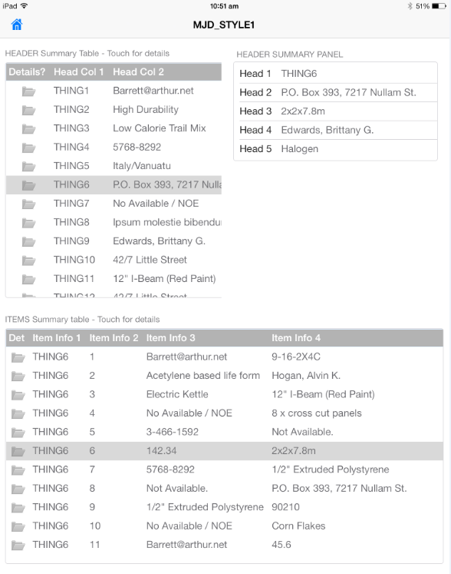
Defined as an offline/local form view
H BNDDIR('LRNGSRV') DFTACTGRP(*no) ACTGRP(*caller)
H BNDDIR('EZISERVICE')
/INCLUDE LRNGSOURCE,LRNGCOMMON
/INCLUDE QRPGLESRC,EZISERVICE
/INCLUDE SOURCEDEMO,DEMOCOMMON
* --------------------------------------------------------------------
* Define the Head_Table
D Head_Table Ds LikeDS(EZI_QTable) Inz(*LikeDS)
D Head_Option1 Ds LikeDS(EZI_Image) Inz(*LikeDS) Note Image type
D Head_Column1 Ds LikeDS(EZI_Label) Inz(*LikeDS)
D Head_Column2 Ds LikeDS(EZI_Label) Inz(*LikeDS)
* --------------------------------------------------------------------
* Define the Header details panel
D Head_Panel Ds LikeDS(EZI_QPanel) Inz(*LikeDS)
D Panel_Elem1 Ds LikeDS(EZI_Label) Inz(*LikeDS)
D Panel_Elem2 Ds LikeDS(EZI_Label) Inz(*LikeDS)
D Panel_Elem3 Ds LikeDS(EZI_Label) Inz(*LikeDS)
D Panel_Elem4 Ds LikeDS(EZI_Label) Inz(*LikeDS)
D Panel_Elem5 Ds LikeDS(EZI_Label) Inz(*LikeDS)
* --------------------------------------------------------------------
* Define the Item_Table
D Item_Table Ds LikeDS(EZI_QTable) Inz(*LikeDS)
D Item_Option1 Ds LikeDS(EZI_Image) Inz(*LikeDS) Note Image type
D Item_Column1 Ds LikeDS(EZI_Label) Inz(*LikeDS)
D Item_Column2 Ds LikeDS(EZI_Label) Inz(*LikeDS)
D Item_Column3 Ds LikeDS(EZI_Label) Inz(*LikeDS)
D Item_Column4 Ds LikeDS(EZI_Label) Inz(*LikeDS)
* --------------------------------------------------------------------
* Standard form view handler parameter list declaration
/INCLUDE SOURCEDEMO,STDPARAMS
/free
// Define the overall form grid layout
LRNG_SetProperties( '/Form.Grid.Col%1.Width:Fill'
: '/Form.Grid.Col%2.Width:Fill'
: '/Form.Grid.Row%1.Height:Fill'
: '/Form.Grid.Row%2.Height:Fill' );
// Define the tables and panels on the form view
Exsr Define_Header_Table;
Exsr Define_Header_Panel;
Exsr Define_Items_Table;
// Send the form view template back and finish.
LRNG_SendReceive(False:RequestPROGRAM:RequestACTION);
*InLR = True;
Return;

// --------------------------------------------------------------------
Begsr Define_Header_Table;

// Position on main form
Head_Table.ParentGRow = 1;
Head_Table.ParentGCol = 1;

// Set up the table column details
Head_Option1.Label = 'Det';
Head_Option1.ResourceorIFSFile = 'tree_view_folder_open_24_gray.png';
Head_Column1.Label = 'Head Col 1';
Head_Column2.Label = 'Head Col 2';
Head_Option1.Label = 'Details?';

// Define the table
Head_Table.Title = 'HEADER Summary Table - Touch for details';
Head_Table.TitleAlign = 'Left';
Head_Table.HighlightCurrentRow = True;
Head_Table.FillColumn = -1;

EZI_QTable_Define( Head_Table
: Head_Option1
: Head_Column1
: Head_Column2 );

// Make the HEADER material bind at the form level as CURRENT_HEADER
LRNG_SetProperty('/Form.&.TBL' : 'HEADER');
LRNG_SetProperty('/Form.&.ASVIEW' : 'CURRENT_HEADER');
LRNG_SetProperty('/Form.&.SQL'
: 'SELECT +
ROWID, HEAD01, HEAD02, HEAD03, HEAD04, HEAD05 +
FROM HEADER' );

// Bind the table rowlist to the TOP_HEADER view of data
EZI_BindProperty( Head_Table:'ROWLIST':'USINGVIEW':'CURRENT_HEADER');

// Bind the table columns to the SQL columns
EZI_BindProperty( Head_Column1 : 'TEXT' : 'FLD' : 'HEAD01');
EZI_BindProperty( Head_Column2 : 'TEXT' : 'FLD' : 'HEAD02');

// Handle touching a row in the header table
LRNG_UsingEx(False:Head_Table.TableElement+'.OnRowClick.Operation');
LRNG_SetProperties( 'Type:ExecSQL'
: 'RefreshForm:Y'
: 'SQL:?CURRENT_HEAD01 = SELECT &(FLD:HEAD01) ');
LRNG_EndUsing();

// Handle touching the open folder icon
LRNG_UsingEx(False:Head_Option1.FullElementName+'.OnClick.Operation');
LRNG_SetProperties( 'Type:OpenForm'
: 'Name:MJD_PANEL1'
: 'PresentMode:Stack');
LRNG_EndUsing();

Endsr;

// --------------------------------------------------------------------
Begsr Define_Header_Panel;

// Position on main form
Head_Panel.ParentGRow = 1;
Head_Panel.ParentGCol = 2;

// Set up the panel elements
Panel_Elem1.Label = 'Head 1';
EZI_QPanel_DefineItem( Head_Panel : Panel_Elem1 );

Panel_Elem2.Label = 'Head 2';
EZI_QPanel_DefineItem( Head_Panel : Panel_Elem2 );

Panel_Elem3.Label = 'Head 3';
EZI_QPanel_DefineItem( Head_Panel : Panel_Elem3 );

Panel_Elem4.Label = 'Head 4';
EZI_QPanel_DefineItem( Head_Panel : Panel_Elem4 );

Panel_Elem5.Label = 'Head 5';
EZI_QPanel_DefineItem( Head_Panel : Panel_Elem5 );

// Define the panel
Head_Panel.Title = 'Header Summary Panel';
EZI_QPanel_Define( Head_Panel );

// Bind the panel elements to the SQL values retreived

EZI_BindProperty( Panel_Elem1 : 'TEXT' : 'FLD' : 'HEAD01');
EZI_BindProperty( Panel_Elem2 : 'TEXT' : 'FLD' : 'HEAD02');
EZI_BindProperty( Panel_Elem3 : 'TEXT' : 'FLD' : 'HEAD03');
EZI_BindProperty( Panel_Elem4 : 'TEXT' : 'FLD' : 'HEAD04');
EZI_BindProperty( Panel_Elem5 : 'TEXT' : 'FLD' : 'HEAD05');

Endsr;

// --------------------------------------------------------------------
Begsr Define_Items_Table;

// Position on main form
Item_Table.ParentGRow = 2;
Item_Table.ParentGCol = 1;
Item_Table.Cols = -1;

// Set up the table column details
Item_Option1.Label = 'Det';
Item_Option1.ResourceorIFSFile = 'tree_view_folder_open_24_gray.png';
Item_Column1.Label = 'Item Info 1';
Item_Column2.Label = 'Item Info 2';
Item_Column3.Label = 'Item Info 3';
Item_Column4.Label = 'Item Info 4';

// Define the table
Item_Table.Title = 'ITEMS Summary table - Touch for details';
Item_Table.TitleAlign = 'Left';
Item_Table.HighlightCurrentRow = True;
EZI_QTable_Define( Item_Table
: Item_Option1
: Item_Column1
: Item_Column2
: Item_Column3
: Item_Column4 );

// Bind the ROWLIST property of the item table to the SQL command used to fill the table
EZI_BindProperty( Item_Table : 'ROWLIST':'TBL' :'ITEMS');
EZI_BindProperty( Item_Table : 'ROWLIST':'ASVIEW':'CURRENT_ITEM');
EZI_BindProperty( Item_Table : 'ROWLIST': 'SQL'
: 'SELECT +
ROWID, ITEM01, ITEM02, ITEM03, ITEM04 +
FROM ITEMS WHERE ITEM01 = &(VAR:CURRENT_HEAD01)');

// Bind the table columns to the SQL values
EZI_BindProperty( Item_Column1 : 'TEXT' : 'FLD' : 'ITEM01');
EZI_BindProperty( Item_Column2 : 'TEXT' : 'FLD' : 'ITEM02');
EZI_BindProperty( Item_Column3 : 'TEXT' : 'FLD' : 'ITEM03');
EZI_BindProperty( Item_Column4 : 'TEXT' : 'FLD' : 'ITEM04');

// Handle touching a row in the items table
LRNG_UsingEx(False:Item_Table.TableElement+'.OnRowClick.Operation');
LRNG_SetProperties( 'Type:OpenForm'
: 'Name:MJD_PANEL2'
: 'PresentMode:Stack');
LRNG_EndUsing();
// Handle touching the open folder icon
LRNG_UsingEx(False:Item_Option1.FullElementName+'.OnClick.Operation');
LRNG_SetProperties( 'Type:OpenForm'
: 'Name:MJD_PANEL2'
: 'PresentMode:Stack');
LRNG_EndUsing();

Endsr;

/end-free

