This example demonstrates a generic way to enable information ‘sharing’ by e-mail or message(SMS).
Imagine an in-field staff member using your iPhone or iPad App wants to:
- ‘Share’ the details of an overdue Order with your billing department by e-mail
- ‘Share’ the details of a customer with another sales rep by SMS
- ‘Share’ the details of a spare part enquiry with a potential customer by SMS

Here is a screen that mocks up all 3 of those situations ........
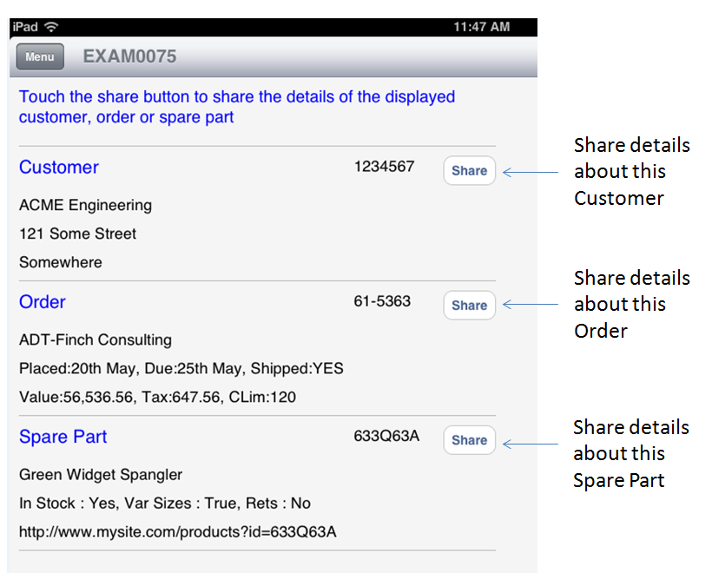

When the user touches the Spare Part’s ‘Share’ button a pop over appears asking whether they want to share the details by by e-mail or message (sms) ..........
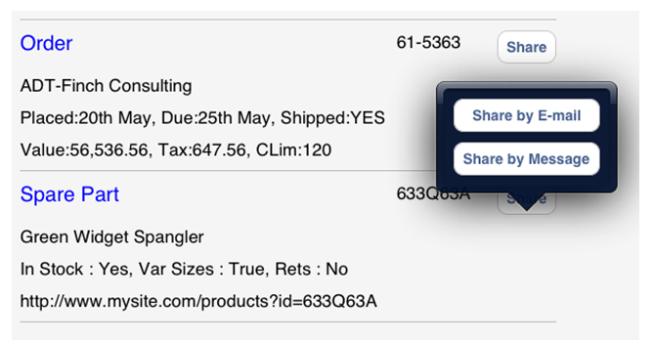
When they touch “Share by E-mail” an e-mail message prefilled with the share details is presented read to send .........
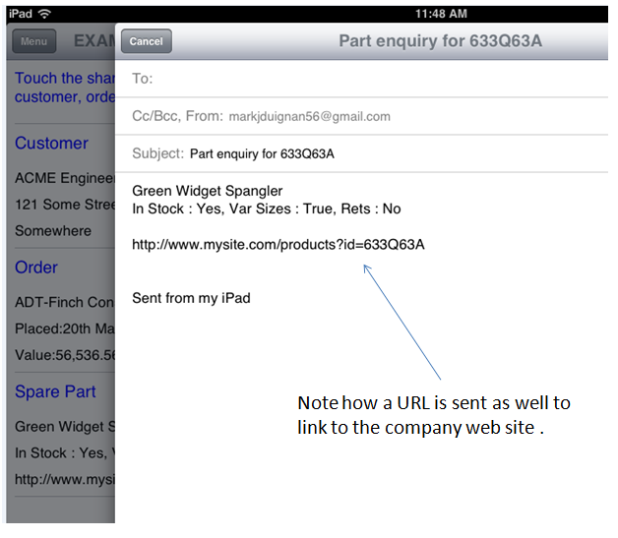
In this case what is ‘shared’ in the e-mail is very similar to what was on the screen – but you can of course share more or less details than were visible on the screen.
The following code is useful because it is generic – you could use some thing like it to add a ‘sharing’ capability to your existing Form Views in a very short time.

EXAM0075A (RPG) – Generic Subroutine - Sets up share button(s) on any screen

H BNDDIR('LRNGSRV') DFTACTGRP(*no) ACTGRP(*caller)
* Data structures, variables, constants and prototypes
D/INCLUDE LRNGSOURCE,LRNGCOMMON
D/INCLUDE SOURCEDEMO,DEMOCOMMON
C* Parameter list declaration
C *Entry PLIST
C Parm Container 256
C Parm Title 256
C Parm Message 256
/free

/// This generic program inserts a share button into the
/// caller's form view. The caller provides the fully qualified
/// <<Name>> of the container on its screen that will have the
/// button inserted. The caller also provides the message that
/// should be shared if the user touches the button

// Set up the associated container with a button

LRNG_Using(%trim(Container));
LRNG_SETProperty('Type' : 'Button');
LRNG_SetProperty('OnClick' : 'EXAM0075B_SHOW_SHARE_METHODS');
LRNG_SetProperty('Text' : 'Share' ) ;
LRNG_SetProperty('OnClick.Param%1' : %trim(Container));
LRNG_SetProperty('OnClick.Param%2' : %trim(Title));
LRNG_SetProperty('OnClick.Param%3' : %trim(Message));
LRNG_EndUsing();

// Finished

*InLR = False;
Return;

/end-free

EXAM0075B (RPG) – Generic Subroutine - Handle the user touching a share button on any screen

H BNDDIR('LRNGSRV') DFTACTGRP(*no) ACTGRP(*caller)
* Data structures, variables and prototypes
D/INCLUDE LRNGSOURCE,LRNGCOMMON
D PNL C X'25'
D DS
D Container 256A
D Title 256A
D Message 256A
D/INCLUDE SOURCEDEMO,DEMOCOMMON
C* Parameter list declaration
C *Entry PLIST
C Parm RequestACTION 32
/free

/// This generic program acts in concert with EXAM0075A. It handles the
/// user touching the button 'Share' button to share details.

if (RequestACTION = 'EXAM0075B_SHOW_SHARE_METHODS');
Exsr SHOW_SHARE_METHODS;
endif;

// Finished

*InLR = False;
Return;

/// ----------------------------------------------------------
/// Create the form required to select E-Mail or SMS
/// ----------------------------------------------------------
//
Begsr SHOW_SHARE_METHODS;
// Get the associated event parameter details that would
// have been set up by EXAM0075A. These tell this program
// the visual container that initiated the request and
// the title and message of what is to be shared

LRNG_Using('/CurrentOp');
LRNG_GetProperty('Param%1' : Container : %size(Container));
LRNG_GetProperty('Param%2' : Title : %size(Title));
LRNG_GetProperty('Param%3' : Message : %size(Message));
LRNG_EndUsing();

// Build the pop over form with the e-mail and SMS button options

LRNG_Using(%trim(Container));

LRNG_SETProperty('ShowPopOver':'True');

LRNG_Using('PopOver');

// The pop over is a form by itself
LRNG_SetProperty('Type' : 'Form');
LRNG_SetProperty('BackColor' : '&0d1a35');

// Add the e-mail button
LRNG_Using('Fields.EMAIL');
LRNG_SetProperty('Type' : 'Button');
LRNG_SetProperty('Text' : 'Share by E-mail');
LRNG_SetProperty('Layout.Row' : '1');
LRNG_Using('OnClick.Operation');
LRNG_SetProperty('Type' : 'SendMail');
LRNG_SetProperty('Subject' : Title);
LRNG_SetProperty('Body' : Message);
LRNG_EndUsing();
LRNG_EndUsing();

// Add the sms button
LRNG_Using('Fields.SMS');
LRNG_SetProperty('Type' : 'Button');
LRNG_SetProperty('Text' : 'Share by Message');
LRNG_SetProperty('Layout.Row' : '2');
LRNG_Using('OnClick.Operation');
LRNG_SetProperty('Type' : 'SendTextMessage');
LRNG_SetProperty('Message' : %trimr(Title)+PNL+Message);
LRNG_EndUsing();
LRNG_EndUsing();

LRNG_EndUsing();

Endsr;

/end-free

EXAM0075D (DSPF) and EXAM0075 (RPG) – Mock up Form View to demonstrate use of the generic subroutines

A DSPSIZ(27 132)
A* -----------------------------------------------------------------------
A R FORMVIEW
A* Put the details of a dummy customer, order, invoice and part
A* on the screen. beside each create a <<tag>> name that EXAM0075A
A* will dynamically convert to a 'Share'button
A 2 10'<<TITLE>>'
A 2 10HTML('Type:Label Color:Blue
A Font.size:18 Layout.Cols:-1 ')
A* A dummy example customer
A 4 10HTML('Type:Label BackColor:&b8bbbf
A Layout.Height:1 Layout.Cols:-1')
A 5 10'Customer'
A 5 10HTML('Color:Blue Font.Size:20')
A CUSTNUM 10 O 5 40
A 5 60'<<CUSTOMER_SHARE>>'
A CUST01 50 6 10
A CUST02 50 7 10
A CUST03 50 8 10
A* A dummy example order number
A 9 10HTML('Type:Label BackColor:&b8bbbf
A Layout.Height:1 Layout.Cols:-1')
A 10 10'Order'
A 10 10HTML('Color:Blue Font.Size:20')
A ORDERNUM 10 O 10 40
A 10 60'<<ORDER_SHARE>>'
A ORDR01 50 11 10
A ORDR02 50 12 10
A ORDR03 50 13 10
A* A dummy example spare part number
A 14 10HTML('Type:Label BackColor:&b8bbbf
A Layout.Height:1 Layout.Cols:-1')
A 15 10'Spare Part'
A 15 10HTML('Color:Blue Font.Size:20')
A PARTNUM 10 O 15 40
A 15 60'<<PART_SHARE>>'
A PART01 50 16 10
A PART02 50 17 10
A PART03 50 18 10
A 19 10HTML('Type:Label BackColor:&b8bbbf
A Layout.Height:1 Layout.Cols:-1')

H BNDDIR('LRNGSRV') DFTACTGRP(*no) ACTGRP(*caller)
* RPG file declarations - includes all form view definition(s)
FEXAM0075D CF E WORKSTN
* Standard include to bring in the external LRNG support functions
/INCLUDE LRNGSOURCE,LRNGCOMMON
* Standard demonstration definitions and prototypes
/INCLUDE SOURCEDEMO,DEMOCOMMON
* Local Variables
D PLF C X'25'
* Standard form view handler parameter list declaration
/INCLUDE SOURCEDEMO,STDPARAMS
* Use free format coding style
/free

// Set up dummy customer, order, invoice and part numbers to act as
// examples of the type of data that might be displayed by this program
// ready for sharing via e-mail or SMS

CustNum = '1234567';
Cust01 = 'ACME Engineering';
Cust02 = '121 Some Street';
Cust03 = 'Somewhere';

OrderNum = '61-5363';
Ordr01 = 'ADT-Finch Consulting';
Ordr02 = 'Placed:20th May, Due:25th May, Shipped:YES';
Ordr03 = 'Value:56,536.56, Tax:647.56, CLim:120';

PartNum = '633Q63A';
Part01 = 'Green Widget Spangler';
Part02 = 'In Stock : Yes, Var Sizes : True, Rets : No';
Part03 = 'http://www.mysite.com/products?id=633Q63A';

// Loop for as long as this program is the one handling the requests
DoU (RequestPROGRAM <> ProgramINFO.Name);
// Handle the requested action
Exsr HandleRequestedAction;
// Display the resulting form view
Exsr DisplayFormView;
Enddo;
// Return control back to the driver
*InLR = True;
Return;

// ======================================================================
// HandleRequestedAction : Handle the user's requested action
// ======================================================================

Begsr HandleRequestedAction;

// Initially assume that the information displayed will be changed
IsNewForm = True;

// Now handle the user's requested action (found in RequestACTION)
Select;

// If the user has requested to see RPG or DDS Code
// NOTE: This code would not be in a real application of course!
When ( %Subst(RequestACTION:1:4) = 'SHOW');
DemoShowMember( SystemInfo : RequestACTION
: ProgramINFO.Name : RequestWasHandled );
IsNewForm = False;

/// If the request starts with EXAM0075B delegate it
When ( %Subst(RequestACTION:1:9) = 'EXAM0075B');
EXAM0075B(RequestACTION);
IsNewForm = False;

// Otherwise set up the 3 different share buttons on the screen
Other;
// Look at the DDS in member EXAM0075D to see these buttons
// The parameters are the name of the button on this screen,
// the title of what is to be shared and the message (content)
// of what is to be shared.

EXAM0075A ('/Form.Fields.ORDER_SHARE'
: 'Your Order : ' + %trimr(OrderNum)
: %trimr(Ordr01)+PLF+%trimr(Ordr02)+PLF+%trimr(Ordr03));

EXAM0075A ('/Form.Fields.CUSTOMER_SHARE'
: 'Details of customer : ' + %trimr(CustNum)
: %trimr(Cust01)+PLF+%trimr(Cust02)+PLF+%trimr(Cust03));

EXAM0075A ('/Form.Fields.PART_SHARE'
: 'Part enquiry for ' + %trimr(PartNum)
: %trimr(Part01)+PLF+%trimr(Part02)+PLF+PLF+%trimr(Part03));

// End of selection
EndSl;

// Set up the title

LRNG_SetProperty('/Form.Fields.TITLE.Value'
: 'Touch the share button to share the details'
+ ' of the displayed customer, order or spare part');

Endsr;

// ----------------------------------------------------------------------
// Display the formview
// ----------------------------------------------------------------------
Begsr DisplayFormView;

// Write out and read back this handler's form view (screen layout).
If (Not IsNewForm);
LRNG_SetSendChangesOnly();
Endif;
LRNG_Send();
// Typically only the DDS record format name is changed or SELECTed.
EXFMT FORMVIEW;
LRNG_Receive();
// Get the next requested action to take and the program to handle it
LRNG_GetRequestedAction(RequestPROGRAM:RequestACTION);
Endsr;

/end-free

