This example demonstrates
- How to create tables with rows that contain more complex multi-line layouts
- How simple code changes can radically alter the appearance of an App.
The example produces screens like this:
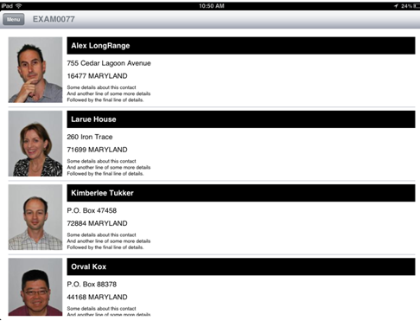
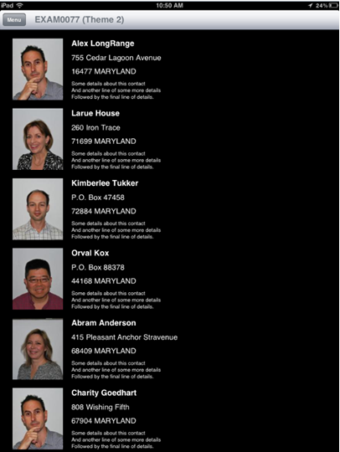
See EXAM0077D (DSPF) and EXAM0077 (RPGLE) attached for the example code.
Form View program EXAM0077 should be enrolled into a test schema twice, like this:
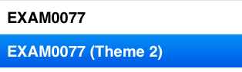
The first enrolment should use initial action DEFAULT
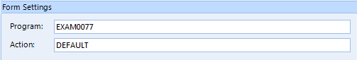
the second should use initial action THEME2 ....


