Adding .lxp MIME Type to IIS

When running LongRange for LANSA on a Windows Server, you will likely have to add a MIME Type to your IIS web server. If you do not, you may get a message on the client app (i.e. LongRange running on the iPad) saying something like “Could not find Schema…”. If you do get this message, first see if you can view a schema on the Windows machine running LongRange for LANSA. For example, try this: http://localhost/images/longrange/schema/LANSADemo.lxp

You should be able to view the content of the schema file (i.e. LANSADemo.lxp) like so:
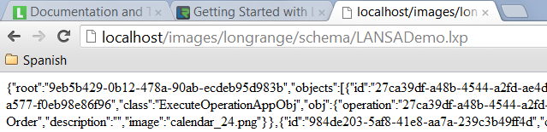

If you can’t view the content of the schema file, follow the steps below to add the .lxp extension as a MIME Type:

Double Click MIME Types:
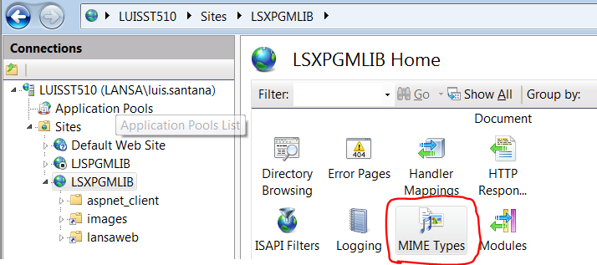

Click Add:
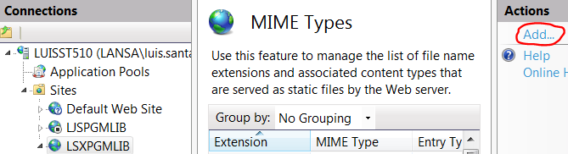

Enter .lxp for File name extension and text/html for MIME type:
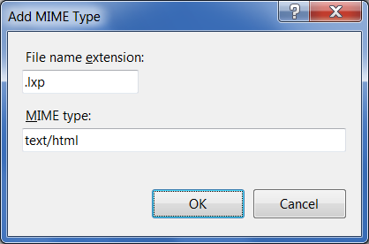

Your MIME Type should look like this:


