This version has some minor improvements and corrections, but the major new feature is the “Example Finder” on the “Programming Examples” menu ....
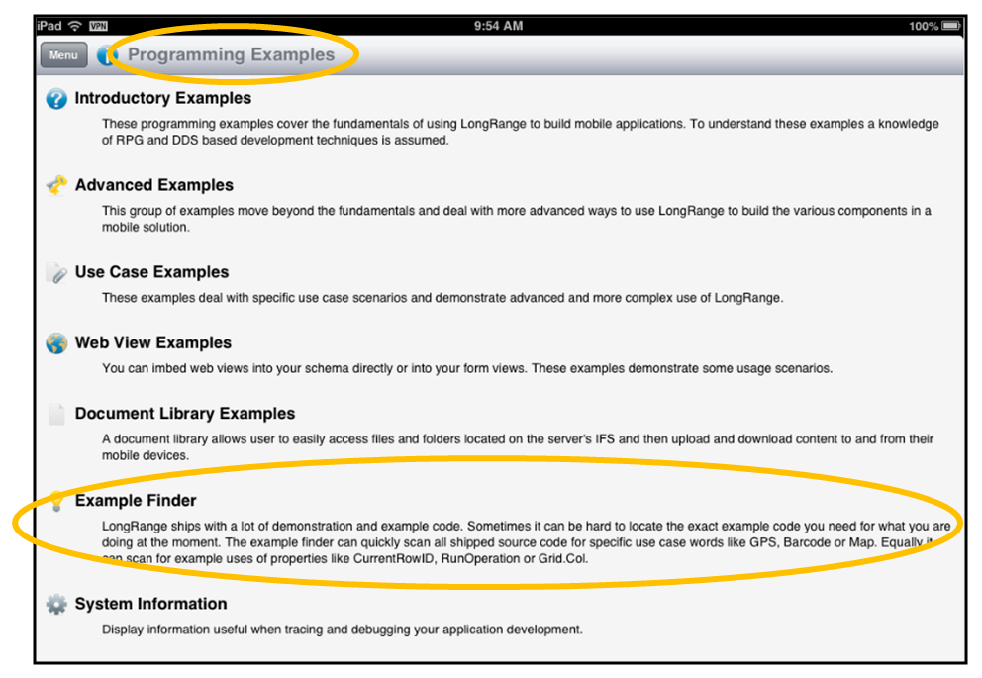
Using it you can search all shipped RPG, COBOL, CL and DDS source code or you can search a set of keywords – or even just select from one of all possible keywords ........
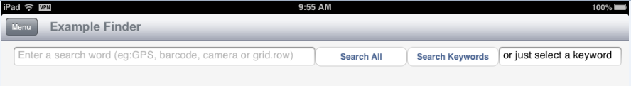

Here keyword BARCODE has been selected from the possible keywords list ...
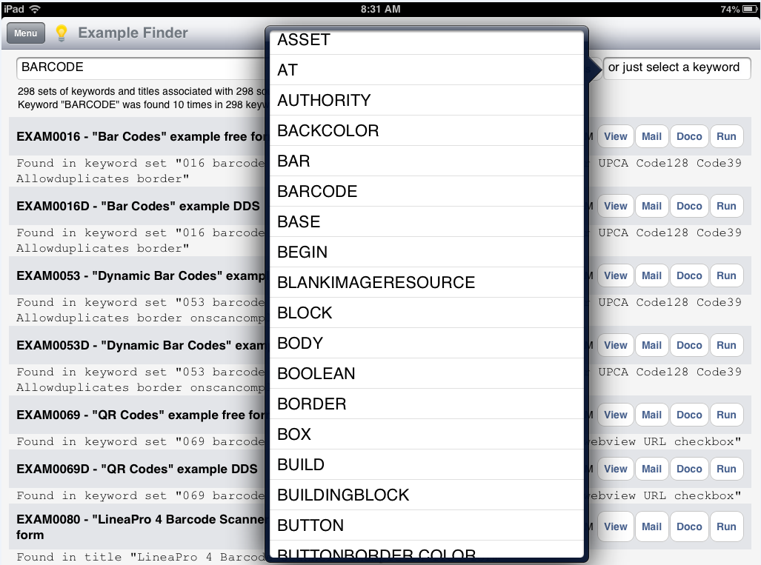
Here the developer is specifically looking for some code that uses the Grid.Row property ...
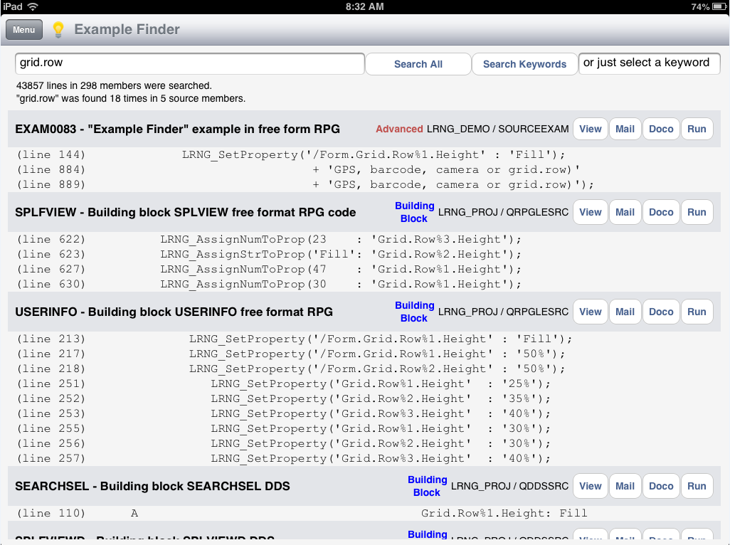
When source members are displayed ...
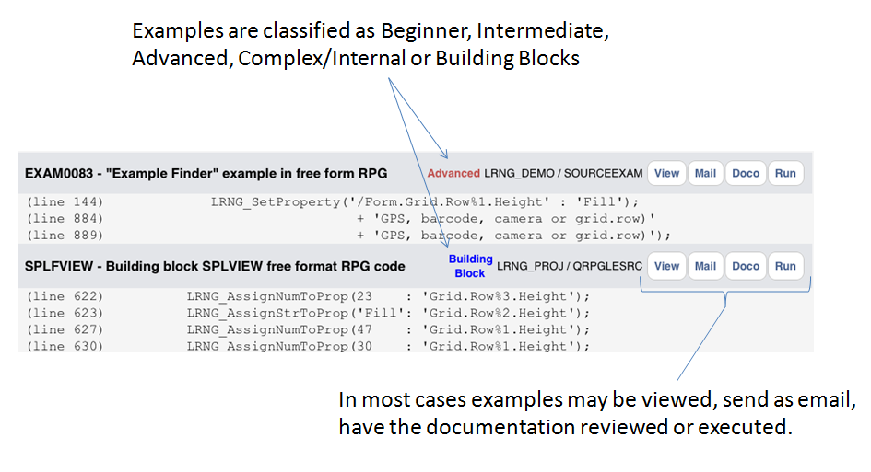
Note 1: The “Example Finder” source code is itself shipped as an example (EXAM0083).
Note 2: The “Example Finder” is not available on small screen devices. You will see


