Producing and Emailing a Client Side Log File

A client side log is rarely useful to problem analysis – so only use these procedures when specifically requested by LANSA support.
First make sure you have can send e-mails from your device – if necessary set up a G-Mai l or Hot Mail account.
Then start your LongRange application and touch the Settings spanner image:
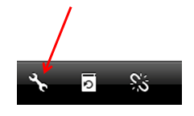
On the Settings panel touch the Troubleshooting & Support option:
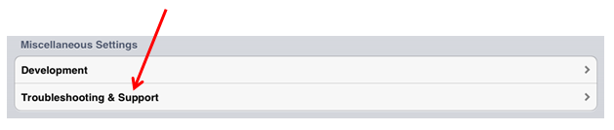
On the Troubleshooting & Support panel enable both logging and verbose logging:
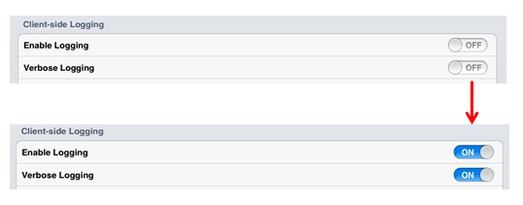
Use  on the left and then  on the right to return to your application.
Execute the problem area of area of your application while logging is turned on.
Use the settings spanner  to redisplay the Settings panel. Display the Troubleshooting and Support panel again and touch the Email Log File option:
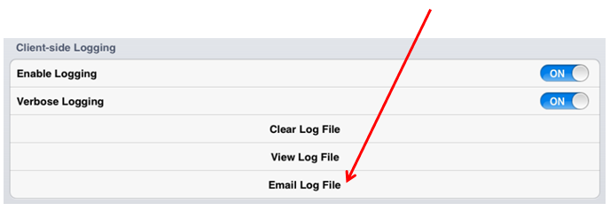
Send the log file in an e-mail to your LANSA support person:
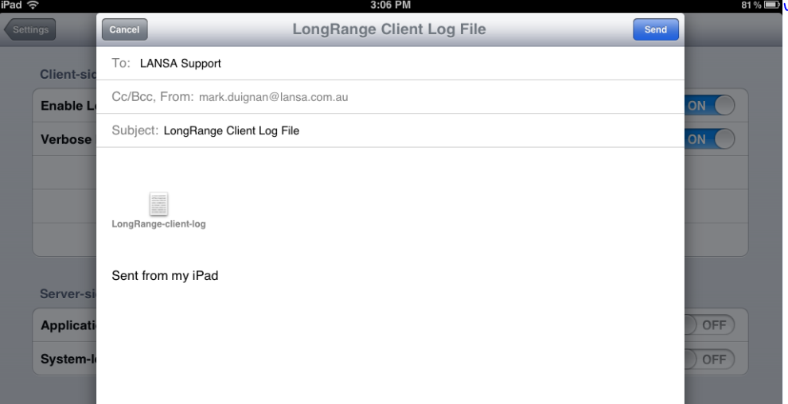
Turn off logging again and clear the log file – noting that clearing the log file will close your LongRange application.
When restarting double check that both logging options are now turned off again:


